***Operating Systems***

***Lab Work***

***Practical 2***

***Name :Shrey Vyas***

***Batch:F-1***

***Roll Number:22BCE335***

Using if Condition:

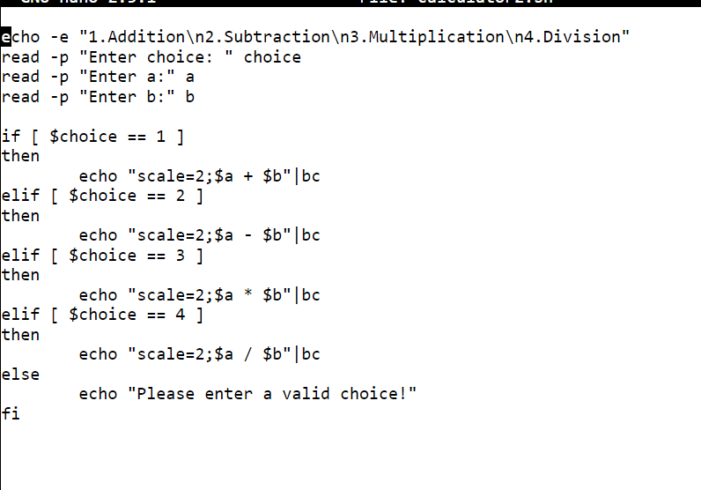

Using Case Structure:

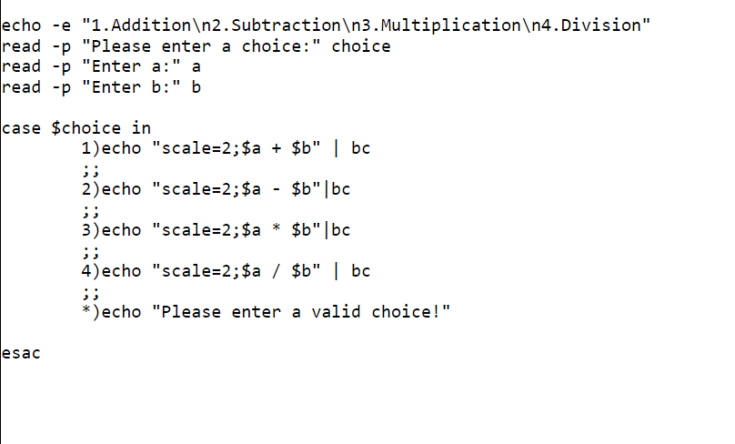

Output:

